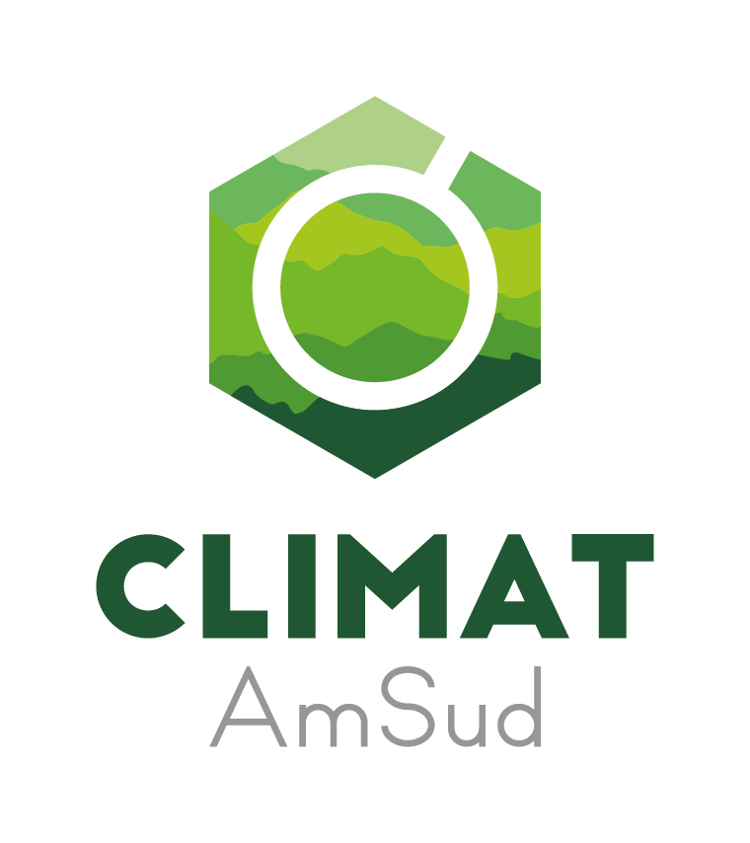
Regional Program CLIMAT-AmSud
2022 Project Proposal (Research – Innovation)

Basic Form
- This form, and the associated CVs, must be filled in English. Before filling the form, please read carefully the bases published in the AmSud website (http://sticmathamsud.org/).

A. General Information

A1 | Project title

A2 | Acronym

A3 | Research domain

A4 | Project goals

A5 | Abstract

A6 | National coordinators at each institution
 | South America A |  |  | South America B
 | Institution |  |  | Institution
 | Project coordinator |  |  | Project coordinator
 | Address |  |  | Address
 | Phone/Fax |  |  | Phone/Fax
 | Email |  |  | Email
 | South America C |  |  | South America D
 | Institution |  |  | Institution
 | Project coordinator |  |  | Project coordinator
 | Address |  |  | Address
 | Tel/Fax |  |  | Tel/Fax
 | Email |  |  | Email
 | France A |  |  | France B
 | Institution |  |  | Institution
 | Project coordinator |  |  | Project coordinator
 | Address |  |  | Address
 | Tel/Fax |  |  | Tel/Fax
 | Email |  |  | Email

A7 | Other participating institutions
 | In South America | In France

A8 | List of expected participants (name and affiliation and status : junior, senior )

A9 | International Project Coordinator (to be chosen among the national Coordinators mentioned in A6)

B. Project Details
B1. Project guidelines

B2. Project description
Goals, motivation, methodology and contribution of each participating institution

Project scope

Expected results

B3. Schedule, with main execution stages

B4. Contributions
Present contributions so as to highlight the role of each partner and the integration among partners.

B5. Regional Aspects
Indicate how the activities will stimulate effective scientific interactions between all the participants.

B6. Dissemination plan
Indicate the planned actions to disseminate the scientific results beyond the scientific literature notably for political actors and/or civil society and indicate how the CLIMAT AmSud program will be mentioned in those activities.

B7. Additional information
List all the complementary fundings expected or already obtained.

Experience of the coordinators in similar projects.

Present main activities and their relationship with the project’s main goal.

Perspectives of continuing collaboration after project financing is over.

Present how you plan to disseminate the results in the public and politic sphere

B8. Public and private support obtained related to the project:
Participation in a previous STIC AmSud, MATH AmSud or CLIMAT AmSud project?
YES NO

Other public support in the past (ECOS, COFECUB, CNRS, European Union, etc.):

Other private support in the past:

Prospects for public or private support in the future:

C. Project Budget

Project title:

Participating institutions:

The CLIMAT-AmSud program funds travel expenses (air tickets and per diem) to researchers in research missions and workshops.

C1. First year (2023)

Planned missions – Year 1

Researcher | Status  (student, junior, senior) | Institution | Origin | Destination | Planned date | Duration  (max. 30 days) | Estimated cost of the trip (€) | Estimate of total per diem ( €) | Trip and Mission funding institution | Mission objectives
Ex: Michel Dupont |  | CNRS | Paris | Santiago | - | 30 | 1.500 | 1.500 | CNRS | …

CONSOLIDATED BUDGET: Year 1

Funding requested to the CLIMAT-AmSud Program
Estimated costs (€)

 | - Travel costs (air tickets) | B- Maintenance costs (per diem) | TOTAL
MEAE France
CNRS France
INRIA France

INRAE France
CIRAD France
IRD France
Ministerio de Ciencia, Tecnología e Innovación de Argentina

UMSA Bolivia
CAPES Brazil
ANID Chile
MINCIENCIAS Colombia
CONACYT Paraguay
CONCYTEC Peru
ANII Uruguay

Total requested funding to CLIMAT-AmSud
Other funding
TOTAL

Do you have additional funding sources for this project? (if so please specify the amount and source (s)).
C2. Second year (2024)

Second year funding depends on approval of ongoing report.

Planned missions – Year 2

Researcher | Status  (student, junior, senior) | Institution | Origin | Destination | Planned date | Duration  (max. 30 days) | Estimated cost of the trip (€) | Estimate of total per diem ( €) | Trip and Mission funding institution | Mission objectives
Ex: Pablo Fernandez |  | ANID | Santiago | Paris | - | 30 | 1.500 | 1.500 | ANID | …

CONSOLIDATED BUDGET: Year 2

Funding requested to the CLIMAT-AmSud Program
Estimated costs (€)

 | - Travel costs (air tickets) | B- Maintenance costs (per diem) | TOTAL
MEAE France
CNRS France
INRIA France

INRAE France
CIRAD France
IRD France
Ministerio de Ciencia, Tecnología e Innovación de Argentina

UMSA Bolivia
CAPES Brazil
ANID Chile
MINCIENCIAS Colombia
CONACYT Paraguay
CONCYTEC Peru
ANII Uruguay

Total requested funding to CLIMAT-AmSud

Other funding
TOTAL

Do you have additional funding sources for this project? (if so please specify the amount and source (s)).
C3. BUDGET TOTALS

 | Year 1 | Year 2 | Total
Funding requested to MEAE (France)
Funding requested to CNRS (France)
Funding requested to INRIA (France)
Funding requested to INRAE (France)
Funding requested to CIRAD (France)
Funding requested to IRD (France)
Funding requested to Ministerio de Ciencia, Tecnología e Innovación (Argentina)
Funding requested to UMSA (Bolivia)
Funding requested to CAPES (Brazil)
Funding requested to ANID (Chile)
Funding requested to MINCIENCIAS (Colombia)
Funding requested to CONACYT (Paraguay)
Funding requested to CONCYTEC (Peru)
Funding requested to ANII (Uruguay)
Matching funds from the partners
Other sources
TOTAL

D. Institutions and CVs of coordinators
Description of each participating institution, and curriculum vitae of the project coordinators (maximum 2 pages per participant).

ANNEX

Model CV (maximum 2 pages)

1/ Personal data
Name:
Birth date:
Professional address (with telephone and e-mail):
Current job title and size of the research group:

2/ Highest obtained degree (with indication of place and date)

3/ Professional activity in the last 5 years

4/ Other duties/ positions

5/ Awards, fellowships and external recognition

6/ Ongoing funded research projects with dates, titles, sources of funding

7/ Projects approved in the least 5 years

8/ Publications
8.1 – Highlight the most important publications related to the project theme
8.2 – Publications in cooperation with the project partners

9/ Theses oriented and post-doctoral fellows supervised
9.1 – Finished/defended in the last 5 years
9.2 – Ongoing

Each institution will pay for the trip and per diem of its own researchers.
Specify in additional page.
Reserved for CNRS researchers
Each institution will pay for the trip and per diem of its own researchers.
Specify in additional page.
Reserved for CNRS researchers

